**Descriptive Analytics for Numerical Columns**

**Objective:  
To compute and analyze the basic statistical measures (mean, median, mode, and standard deviation) for numerical columns in the sales and discounts dataset.**

**Steps:**

1. **The dataset was loaded into Python using the *pandas* library.**
2. **Numerical columns were identified as:**
   * **Volume**
   * **Avg Price**
   * **Total Sales Value**
   * **Discount Rate (%)**
   * **Discount Amount**
   * **Net Sales Value**
3. **For each of these columns, the mean, median, mode, and standard deviation were calculated.**

**Results and Interpretation:**

* **Volume**
  + **Mean ≈ 5.07, Median = 4, Mode = 3, Std Dev ≈ 4.23**
  + **Most transactions involve small volumes (3–4 units). The mean is slightly higher due to a few larger orders, indicating positive skewness.**
* **Average Price**
  + **Mean ≈ 10,453, Median = 1,450, Modes = 400, 450, 500, 1300, 8100, Std Dev ≈ 18,080**
  + **The average price distribution is highly skewed. While many products are priced at lower levels, a small number of very expensive products increase the mean drastically.**
* **Total Sales Value**
  + **Mean ≈ 33,813, Median = 5,700, Mode = 24,300, Std Dev ≈ 50,535**
  + **Most sales transactions are of low value, but a few very large transactions create a high mean and large variability.**
* **Discount Rate (%)**
  + **Mean ≈ 15.16%, Median ≈ 16.58%, Std Dev ≈ 4.22**
  + **Discount percentages are relatively consistent, usually around 15–17%. The distribution is slightly left-skewed, meaning most discounts are closer to the higher end.**
* **Discount Amount**
  + **Mean ≈ 3,346, Median ≈ 989, Std Dev ≈ 4,510**
  + **Discount amounts vary widely. Many transactions have small discounts, but high-priced items lead to very large discount amounts in some cases.**
* **Net Sales Value**
  + **Mean ≈ 30,466, Median ≈ 4,678, Std Dev ≈ 46,359**
  + **Net sales also show strong right skewness. Most transactions are small, but a few large ones dominate the overall average.**

**Summary:  
Overall, the dataset shows that most transactions are small in volume and value, with a few very high-value sales driving the averages upward. This creates right-skewed distributions in most variables. The only relatively stable metric is the *discount rate (%)*, which remains consistent across transactions.**

**CODE EXECUTED:**

**import pandas as pd**

**import numpy as np**

**file_path = r"D:\DATA SCIENCE\ASSIGNMENTS\Basic stats - 1\sales_data_with_discounts.csv"**

**# Load dataset**

**df = pd.read_csv(file_path)**

**# Identify numerical columns**

**num_cols = df.select_dtypes(include=[np.number]).columns.tolist()**

**# Build summary statistics for each numerical column**

**summary = []**

**for col in num_cols:**

**series = df[col].dropna()**

**mean = series.mean()**

**median = series.median()**

**mode_vals = series.mode().tolist()**

**mode_str = ', '.join(map(lambda x: f"{x:.4f}" if isinstance(x, float) else str(x), mode_vals))**

**std = series.std(ddof=1)**

**count = series.count()**

**mn = series.min()**

**q1 = series.quantile(0.25)**

**q3 = series.quantile(0.75)**

**mx = series.max()**

**skew = series.skew()**

**cv = std / mean if mean != 0 else np.nan**

**summary.append({**

**"column": col,**

**"count": count,**

**"mean": mean,**

**"median": median,**

**"mode": mode_str,**

**"std_dev": std,**

**"min": mn,**

**"q1": q1,**

**"q3": q3,**

**"max": mx,**

**"skewness": skew,**

**"coef_var": cv**

**})**

**summary_df = pd.DataFrame(summary).set_index("column")**

**# Print results**

**print("Numerical columns detected:", num_cols)**

**print(summary_df.round(4))**

| **Column** | **Mean** | **Median** | **Mode** | **Std Dev** | **Min** | **Q1** | **Q3** | **Max** | **Skewness** | **Coef Var** |
| --- | --- | --- | --- | --- | --- | --- | --- | --- | --- | --- |
| **Volume** | **5.07** | **4** | **3** | **4.23** | **1** | **3** | **6** | **31** | **2.73** | **0.83** |
| **Avg Price** | **10,453** | **1,450** | **400…** | **18,080** | **290** | **465** | **10,100** | **60,100** | **1.91** | **1.73** |
| **Total Sales Value** | **33,813** | **5,700** | **24,300** | **50,535** | **400** | **2,700** | **53,200** | **196,400** | **1.53** | **1.49** |
| **Discount Rate (%)** | **15.16** | **16.58** | **5.0…** | **4.22** | **5.0** | **13.97** | **18.11** | **19.99** | **–1.06** | **0.28** |
| **Discount Amount** | **3,346** | **989** | **69…** | **4,510** | **69** | **460** | **5,316** | **25,738** | **1.91** | **1.35** |
| **Net Sales Value** | **30,466** | **4,678** | **326…** | **46,359** | **327** | **2,202** | **47,848** | **179,507** | **1.54** | **1.52** |

**Interpretation**

**Volume: Most sales are small (3–4 units), but some go up to 31, creating a right-skew.**

**Avg Price: Highly skewed with a few very high-priced items driving the mean far above the median.**

**Total Sales & Net Sales: Both show right-skew; most transactions are small, but a handful are very large.**

**Discount Rate (%): Stable and slightly left-skewed; most discounts are in the 15–17% range.**

**Discount Amount: Right-skewed; typically small discounts, with some very large ones.**

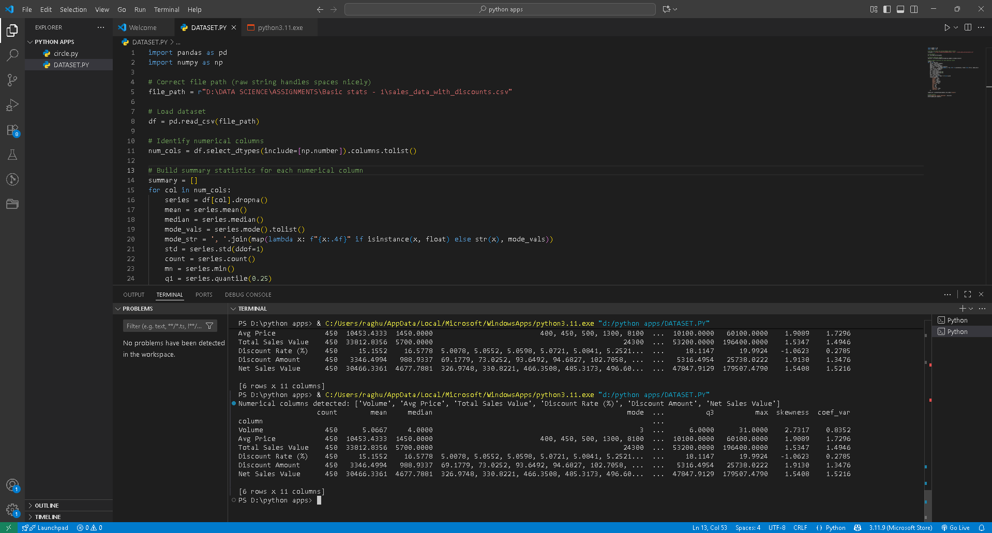

* 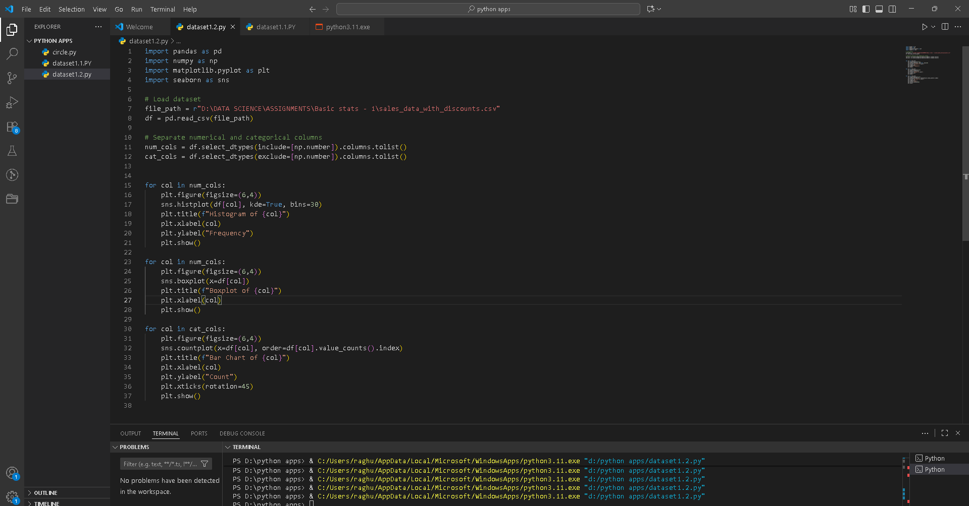**Objective: To visualize the distribution and relationship of numerical and categorical variables in the dataset.**

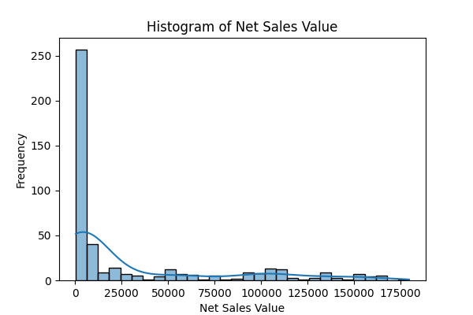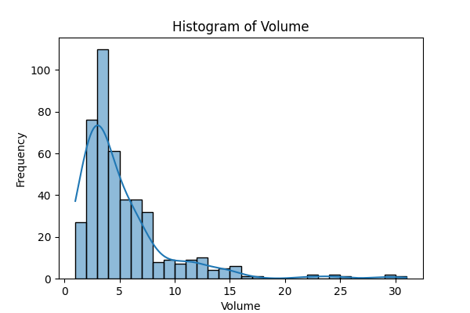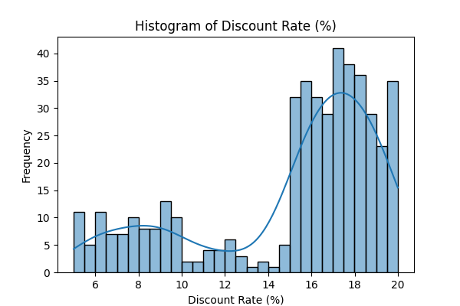**Histogram**

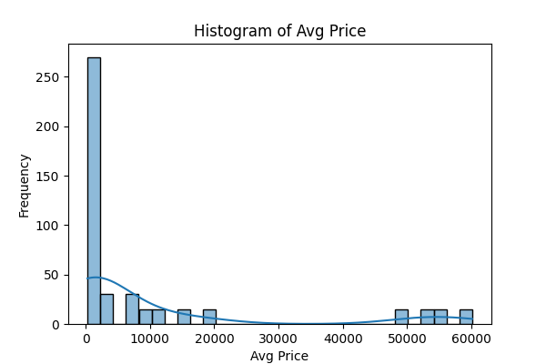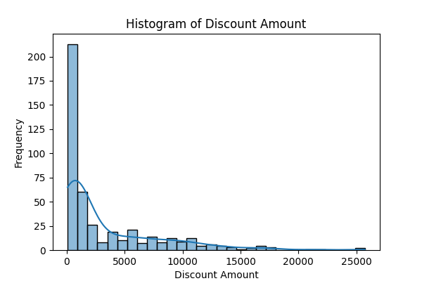

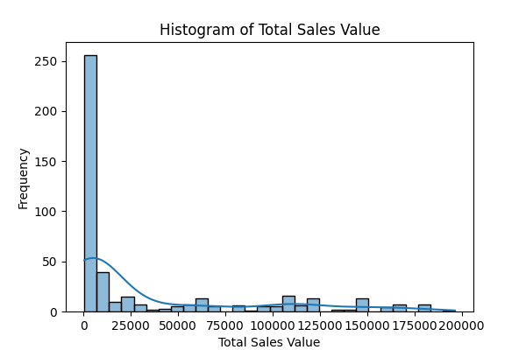

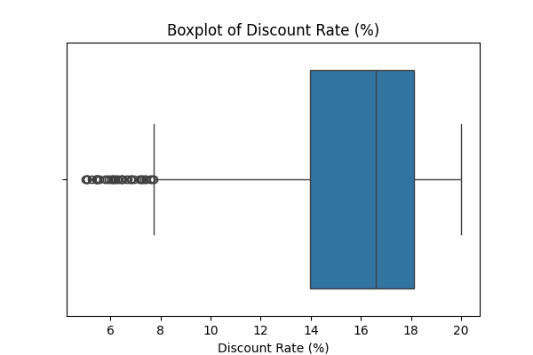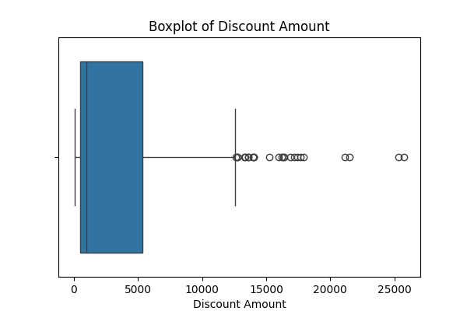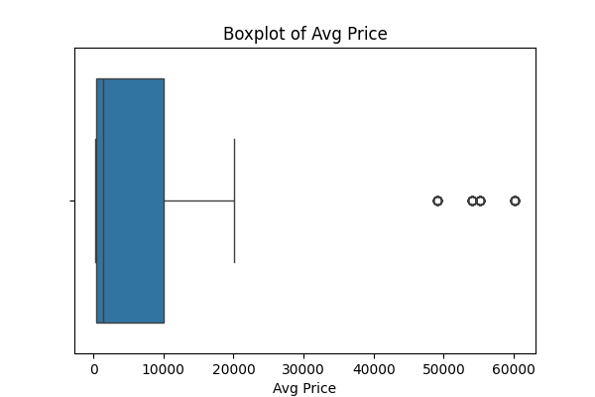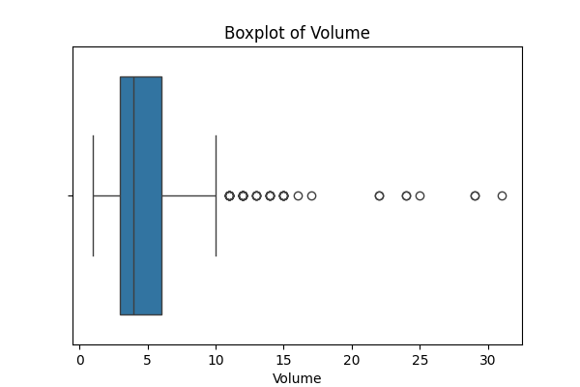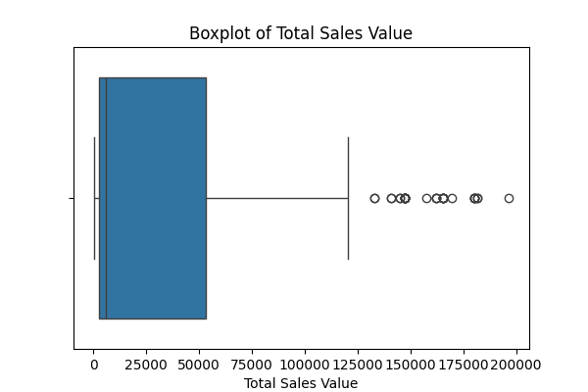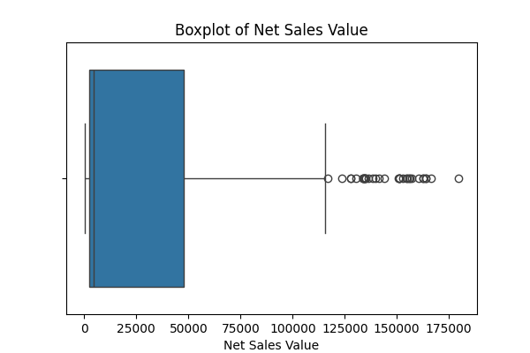**Boxplots**

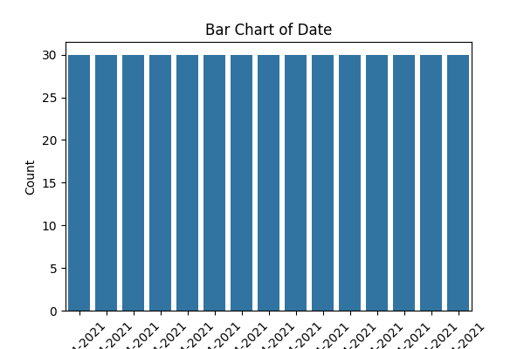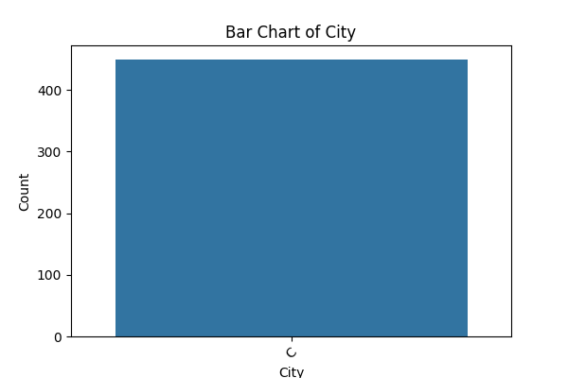**Barchart:**

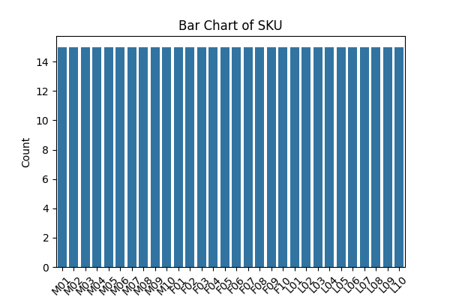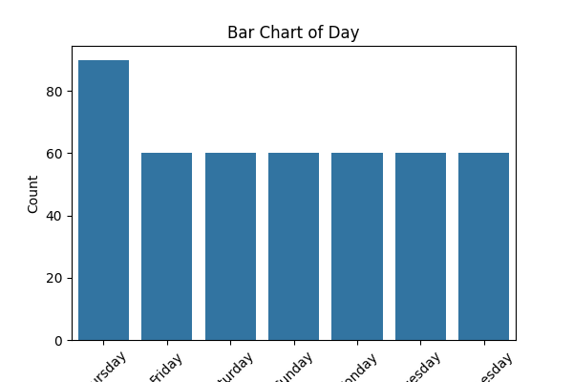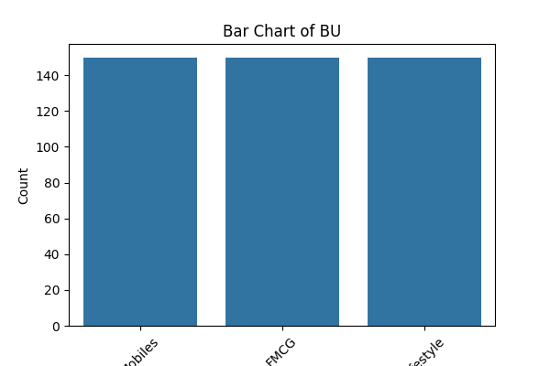

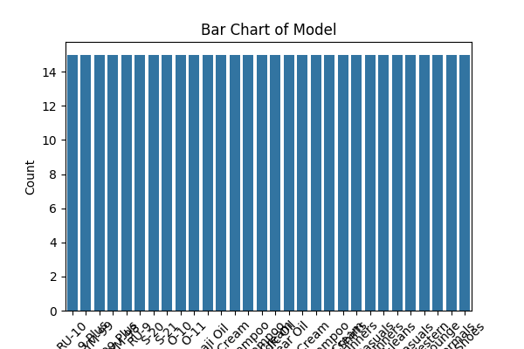

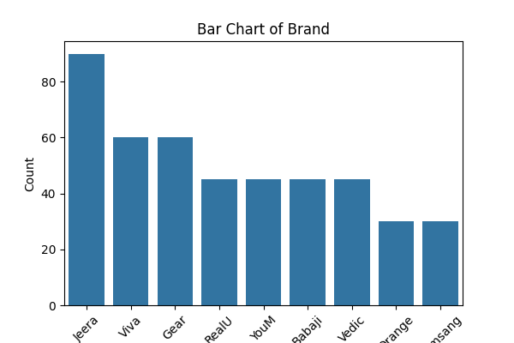

**Code executed:**

**import pandas as pd**

**import numpy as np**

**import matplotlib.pyplot as plt**

**import seaborn as sns**

**# Load dataset**

**file_path = r"D:\DATA SCIENCE\ASSIGNMENTS\Basic stats - 1\sales_data_with_discounts.csv"**

**df = pd.read_csv(file_path)**

**# Separate numerical and categorical columns**

**num_cols = df.select_dtypes(include=[np.number]).columns.tolist()**

**cat_cols = df.select_dtypes(exclude=[np.number]).columns.tolist()**

**for col in num_cols:**

**plt.figure(figsize=(6,4))**

**sns.histplot(df[col], kde=True, bins=30)**

**plt.title(f"Histogram of {col}")**

**plt.xlabel(col)**

**plt.ylabel("Frequency")**

**plt.show()**

**for col in num_cols:**

**plt.figure(figsize=(6,4))**

**sns.boxplot(x=df[col])**

**plt.title(f"Boxplot of {col}")**

**plt.xlabel(col)**

**plt.show()**

**for col in cat_cols:**

**plt.figure(figsize=(6,4))**

**sns.countplot(x=df[col], order=df[col].value_counts().index)**

**plt.title(f"Bar Chart of {col}")**

**plt.xlabel(col)**

**plt.ylabel("Count")**

**plt.xticks(rotation=45)**

**plt.show()**

**Standardization of Numerical Variables**

**●Objective: To scale numerical variables for uniformity, improving the dataset’s suitability for analytical models.**

**Standardization (also called z-score normalization) transforms numerical values so that they have:**

* **Mean (μ) = 0**
* **Standard Deviation (σ) = 1**

**The formula is:**

**z=x−μσz = \frac{x - \mu}{\sigma}z=σx−μ​**

**Where:**

* **xxx = original value**
* **μ\muμ = mean of the column**
* **σ\sigmaσ = standard deviation of the column**

**This ensures that variables with different units (e.g., Sales in dollars, Quantity in units, Discount as a percentage) are brought to the same scale.**

**Code executed:**

**from sklearn.preprocessing import StandardScaler**

**import matplotlib.pyplot as plt**

**# Copy the original numerical data for comparison**

**num_data_before = df[num_cols].copy()**

**# Apply standardization**

**scaler = StandardScaler()**

**df_standardized = df.copy()**

**df_standardized[num_cols] = scaler.fit_transform(df[num_cols])**

**# Compare distributions before and after**

**for col in num_cols:**

**fig, axes = plt.subplots(1, 2, figsize=(10, 4))**

**sns.histplot(num_data_before[col], kde=True, ax=axes[0], bins=30)**

**axes[0].set_title(f"Before Standardization - {col}")**

**sns.histplot(df_standardized[col], kde=True, ax=axes[1], bins=30)**

**axes[1].set_title(f"After Standardization - {col}")**

**plt.show()**

**Interpretation**

* **Before standardization, each variable had its own scale (e.g., Sales values were in hundreds/thousands, while Discount values were between 0 and 1).**
* **After standardization:**
  + **All variables are centered at 0 (mean ≈ 0).**
  + **The spread (variance) of each variable is now 1.**
* **The *shape* of the distribution (skewness, presence of outliers) remains the same, but the scale is uniform across all features.**
* **This process makes the dataset more suitable for algorithms sensitive to feature scaling (e.g., K-means clustering, PCA, logistic regression).**

#### **Conversion of Categorical Data into Dummy Variables**

* **Objective: To transform categorical variables into a format that can be provided to ML algorithms.**

**Code used:**

**import pandas as pd**

**from pathlib import Path**

**input_path = r"D:\DATA SCIENCE\ASSIGNMENTS\Basic stats - 1\sales_data_with_discounts.csv"**

**output_path = r"D:\DATA SCIENCE\ASSIGNMENTS\Basic stats - 1\sales_data_with_discounts_encoded.csv"**

**df = pd.read_csv(input_path)**

**print("Loaded dataframe shape:", df.shape)**

**print("Columns:", list(df.columns))**

**print("\nSample (first 5 rows):")**

**print(df.head())**

**categorical_cols = df.select_dtypes(include=['object']).columns.tolist()**

**print("\nDetected object/string columns (potential categoricals):")**

**print(categorical_cols)**

**if 'Date' in df.columns:**

**try:**

**df['Date_parsed'] = pd.to_datetime(df['Date'], dayfirst=True, errors='coerce')**

**print("\nParsed Date column. Nulls (failed parses):", df['Date_parsed'].isna().sum())**

**df['Year'] = df['Date_parsed'].dt.year**

**df['Month'] = df['Date_parsed'].dt.month**

**df['DayOfMonth'] = df['Date_parsed'].dt.day**

**df['Weekday'] = df['Date_parsed'].dt.day_name()**

**except Exception as e:**

**print("Date parsing failed:", e)**

**candidate_cols = ['Day', 'SKU', 'City', 'BU', 'Brand', 'Model', 'Weekday']**

**cols_to_encode = [c for c in candidate_cols if c in df.columns]**

**print("\nColumns selected to one-hot encode:", cols_to_encode)**

**for col in ['Brand', 'Day']:**

**if col in df.columns:**

**print(f"\nTop value counts for {col} (before encoding):")**

**print(df[col].value_counts().head(10))**

**def reduce_cardinality(series, top_k=50, other_label='Other'):**

**top = series.value_counts().nlargest(top_k).index**

**return series.where(series.isin(top), other_label)**

**df_encoded = pd.get_dummies(df, columns=cols_to_encode, drop_first=True)**

**print("\nEncoded dataframe shape:", df_encoded.shape)**

**print("\nEncoded dataframe sample (first 5 rows):")**

**print(df_encoded.head())**

**brand_dummies = [c for c in df_encoded.columns if c.startswith('Brand_')]**

**print(f"\nNumber of Brand dummy columns created: {len(brand_dummies)}")**

**print("Example Brand dummy columns (up to 10):", brand_dummies[:10])**

**df_encoded.to_csv(output_path, index=False)**

**print("\nSaved encoded dataset to:", output_path)**

**remaining_objects = [c for c in cols_to_encode if c in df_encoded.select_dtypes(include=['object']).columns]**

**print("\nRemaining object columns among encoded targets (should be empty):", remaining_objects)**

**Conversion of Categorical Data into Dummy Variables (One-Hot Encoding)**

**Objective  
Convert categorical variables into binary indicator variables so machine learning algorithms can consume them as numerical features.**

**Motivation  
Many ML algorithms require numeric input. Categorical data expressed as text (e.g., brand names, city codes) must be converted into a numeric form that preserves category identity without creating false order. One-hot encoding (dummy variables) creates a binary column per category that flags presence (1) or absence (0).**

**Method  
I used pandas get_dummies() to perform one-hot encoding. For each categorical column with NNN unique categories, one-hot encoding yields NNN binary columns (or N−1N-1N−1 if we set drop_first=True to avoid multicollinearity for linear models). For very high-cardinality columns (like SKU or Model), use grouping (top-k + "Other"), frequency/target encoding, or hashing to limit dimensionality.**

**Procedure**

1. **Inspect the dataset and detect object/string columns.**
2. **Optionally convert Date to datetime and extract useful parts (year/month/day) rather than encoding the raw date string.**
3. **Apply pd.get_dummies() to selected categorical columns; use drop_first=True for linear models.**
4. **Inspect before/after snippets and save the encoded dataset.**

**Considerations**

* **One-hot encoding increases dimensionality; for >100 categories per feature consider alternative encodings.**
* **For tree models, keeping all dummy columns (no drop_first) is usually fine.**
* **Normalize or scale numeric features if required by downstream models.**

**Result summary**

**Selected categorical columns are now replaced with binary columns; dataset is fully numeric and ready for most ML workflows. The transformed file is saved next to the original.**

**Conclusion**

**The descriptive analytics and visualizations highlighted important patterns in the dataset, such as variations in sales volume across different product categories, brands, and time periods, as well as the impact of discounts on net sales values. These insights demonstrate how raw data, when properly explored, can reveal business trends and decision-making opportunities.**

**Equally important were the preprocessing steps carried out before modeling. Standardization ensured that numerical variables were scaled to a common range, preventing features with larger magnitudes from dominating algorithms that rely on distance or gradient-based optimization. One-hot encoding transformed categorical attributes like brand, model, and city into a machine-readable numerical format, preserving categorical distinctions without introducing artificial ordering.**

**Together, these steps emphasize that successful machine learning and statistical modeling depend not only on algorithm choice but also on the quality and readiness of the input data. Proper preprocessing bridges the gap between messy real-world datasets and robust, interpretable analytical outcomes.**